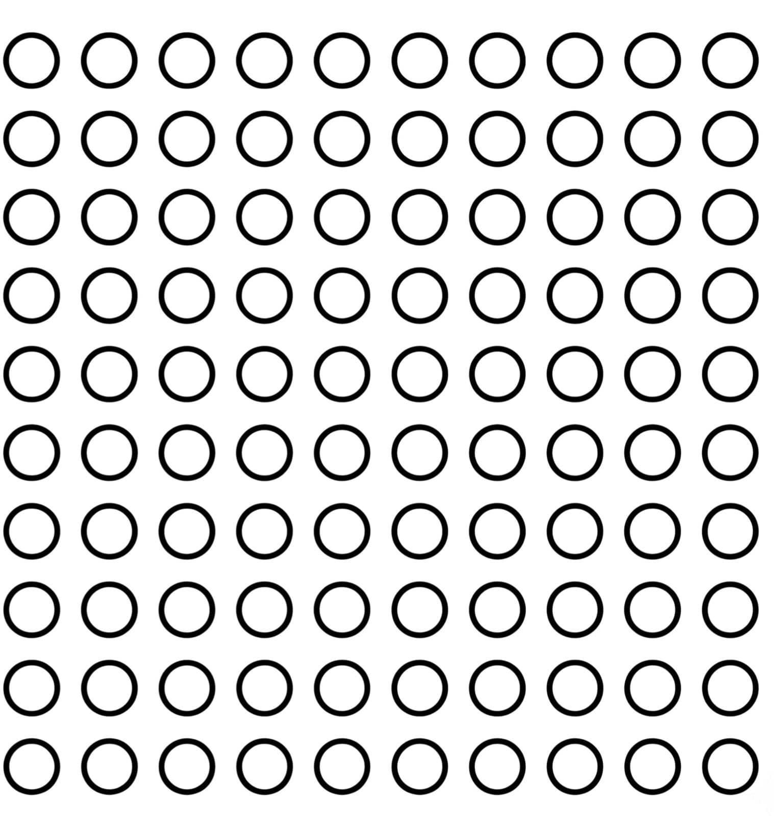
Circle


oval

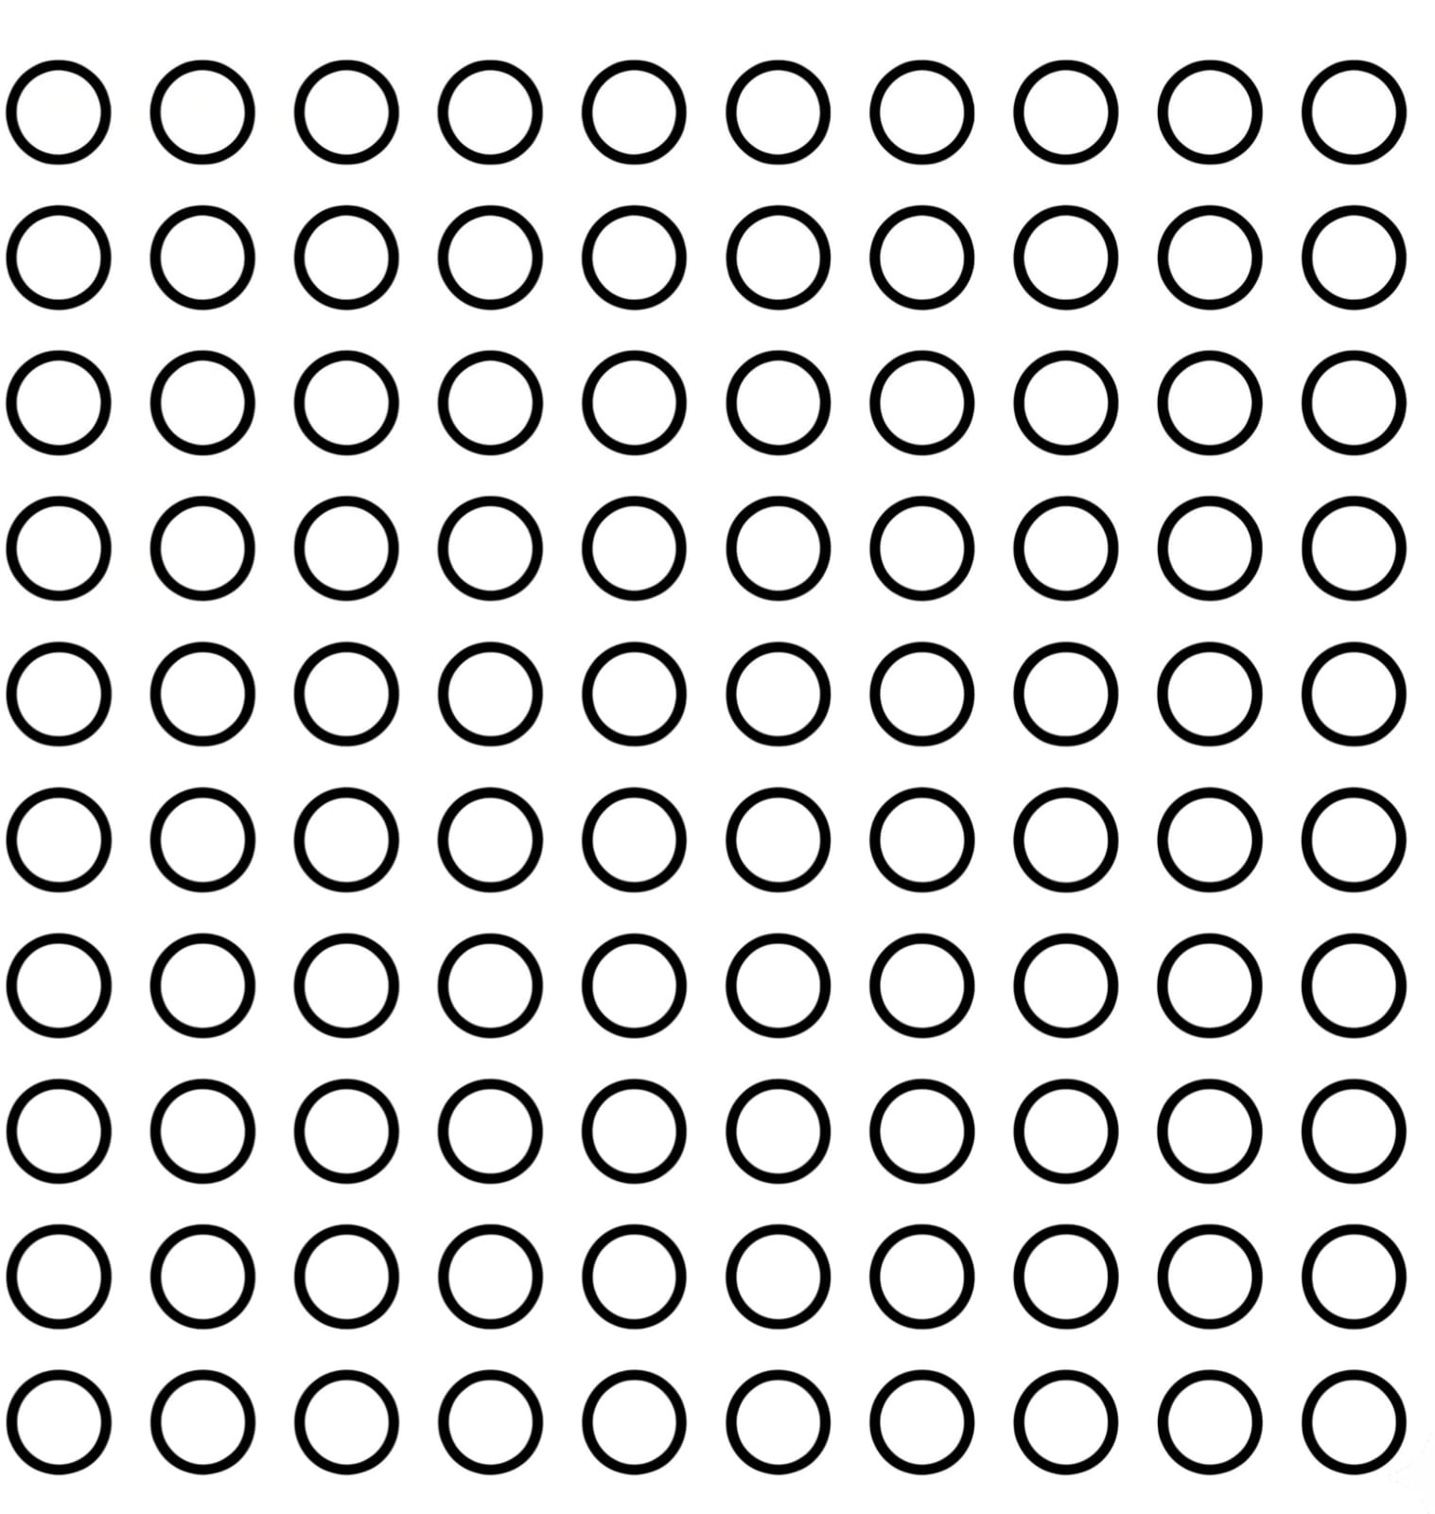
Square


Rhombus


TRIANGLE


SEMI-CIRCLE

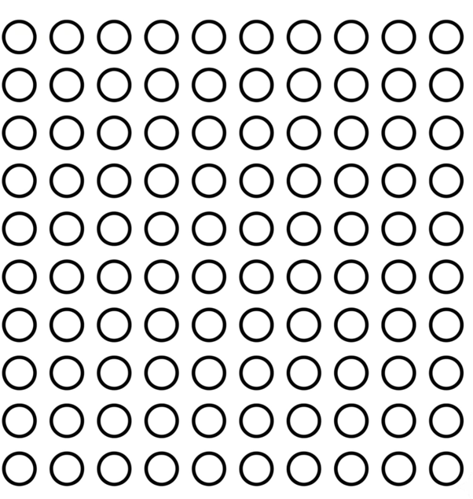
RECTANGLE


TRAPEZOID


star

